FORM CSC(L)

CONSULTANT’S AUTHORIZATION

Date: | | 2

|  |  |  |  |  |  |  |  |  |
| --- | --- | --- | --- | --- | --- | --- | --- | --- |
| Project Name: |  | | | | | | | |
| Location: | Al Ghail Industrial Zone Al Hamra Industrial Zone RAKEZ Academic Zone RAKEZ Business Zone Al Hulaila Industrial Zone Others | | | | | | | |
| Land/Plot Details | | | | | | | | |
| Block No. | | Plot No. | | | Area (Sq.m.) | | | |
|  | |  | | |  | | | |
| Details of Buildings Completed | | | | | | | | |
| Building Name | | No. of Floors | Intended Usage | Area (in square meters) | | | | |
| G.F | | 1/F | 2/F | 3/F(Stair |
|  | |  |  |  | |  |  |  |
|  | |  |  |  | |  |  |  |
|  | |  |  |  | |  |  |  |
|  | |  |  |  | |  |  |  |
|  | |  |  |  | |  |  |  |
|  | |  |  |  | |  |  |  |
|  | |  |  |  | |  |  |  |
|  | |  |  |  | |  |  |  |

This is to certify that the building(s) of the above project is/are completed under the supervision of our engineers and is/are done as per the approved drawings. We also certify that all materials (type and grade) used are in accordance with the approved specifications of UAE/RAK, that the structure(s) is(are) safe and have been checked by qualified engineers/architects and we stand to guarantee the quality of the buildings.

We confirm that the as built drawings submitted along with this is/are validated and attest that the same accurately reflect the actual construction at site.

We further confirm our no objection in client’s application for Building Completion Certificate from RAK Economic Zone and agree to be bound by the authority’s actions deemed applicable should there be false information provided by us which is/are significant to the issuance of the certificate.

Consultant company’s seal/stamp:

Authorized signatory of consultant:

Signature: Name: Designation: Mobile Number:

Issue No: 01

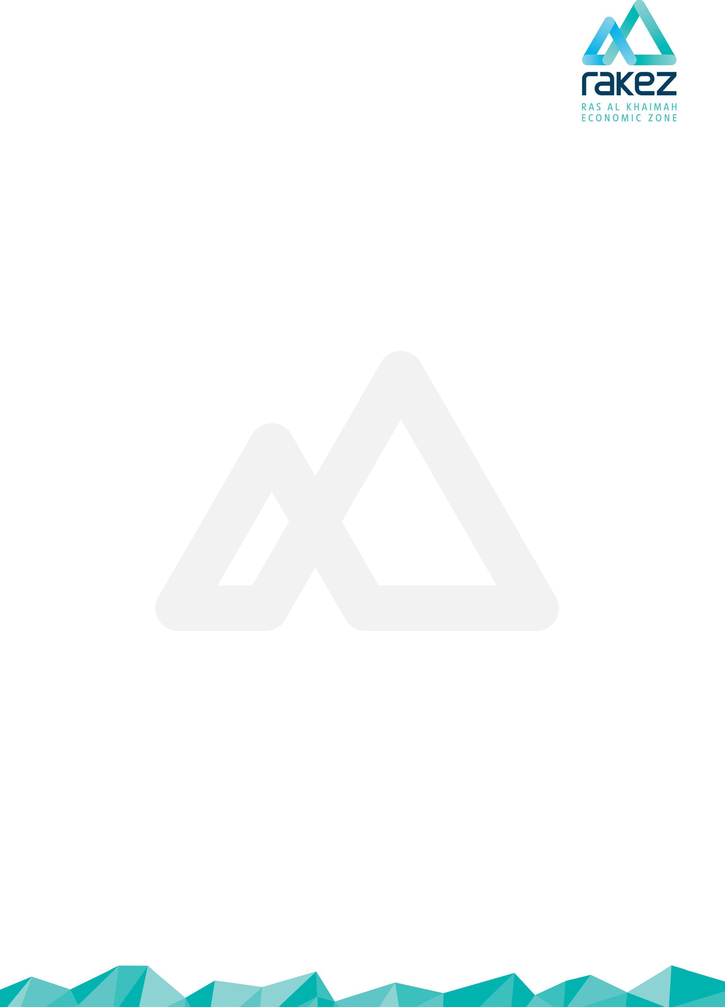

Issue Date: 10 June 2018

Page 1 of 1

Issued by: QM Ref: TSS-019C